NATIONAL INSTITUTE OF TECHNOLOGY, TIRUCHIRAPPALLI

SUMMER RESEARCH INTERNSHIP REPORT

MAY 15 2019 – JULY 22 2019

_________________________________________________________________

**Fault Tolerant Control of a Quadrotor using Super Twisting Sliding Mode Control and Control Allocation**

Indian Institute of Science, Bengaluru

Artificial Intelligence and Robotics Laboratory

Department of Aerospace Engineering

________________________________________________________________

By

BHARATH KUMAR

110116019

BATCH OF 2020

**CONTENTS**

* Acknowledgement
* Objective
* Introduction
* Literature Survey
* Theory
* Methods used
* Results
* Summary

**ACKNOWLEDGEMENT**

I would like to thank Dr Suresh Sundaram, Associate Professor, Department of Aerospace Engineering, IISC Bengaluru for his valuable advice and help throughout the development of this project. Without his guidance and encouragement, this project couldn’t have been materialized. I would also like to thank all the PhD scholars in Artificial Intelligence and Robotics Laboratory, whose assistance was inevitable for the completion of this work.

**OBJECTIVE**

Design a Fault Tolerant Controller for an underactuated quadrotor for safe landing under faulty circumstances

**INTRODUCTION**

Unmanned Aerial Vehicles (UAVs) have gained a lot of interest in recent years. With a wide range of potential applications such as military, disaster management, agriculture, surveillance and environment exploration, UAVs has captured an important place in research and industries. One UAV that has strong potential in any kind of environment is the rotorcrafts. Quadrotor is a rotorcraft with four rotors and is one of the most used aircraft with a myriad of applications.

Sometimes a rotor might get under-actuated due to undesirable environmental effects. This will result in shut down of the plant or this might even endanger the surrounding environment. A solution to such a problem will be designing a Fault Tolerant Control System (FTCS). Such control system will detect the faults occurring in the system and drive the controller in such a way to counter the effect of the faults.

In the following pages, a controller is designed for a quadrotor to track appropriate trajectories and a FTCS is implemented such that the controller is able to control the quadrotor in spite of under-actuation among the rotors. The simulation and results are included at the end of this report.

**THEORY**

**Quadrotor Modelling:**

Let’s assume the model of the quadrotor is as given below. The model is symmetric about all three axes. Such a configuration is usually referred to as “+” configuration. The rotors in opposite sides rotate in the same direction in order to counter the torque.

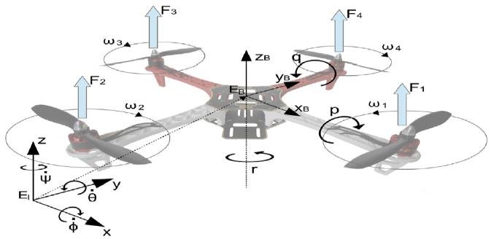

The transformation matrix from body fixed frame to inertial frame be

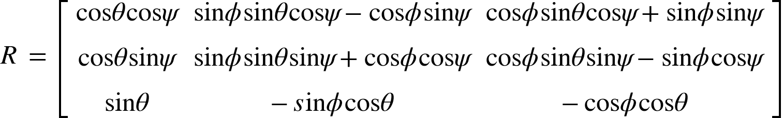

Taking this into account the equations of motion will be

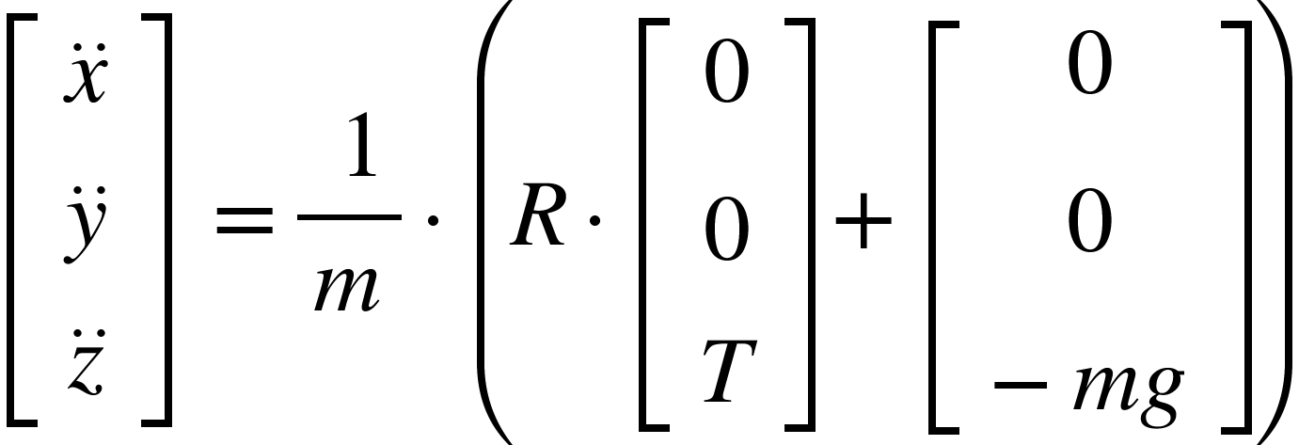

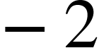

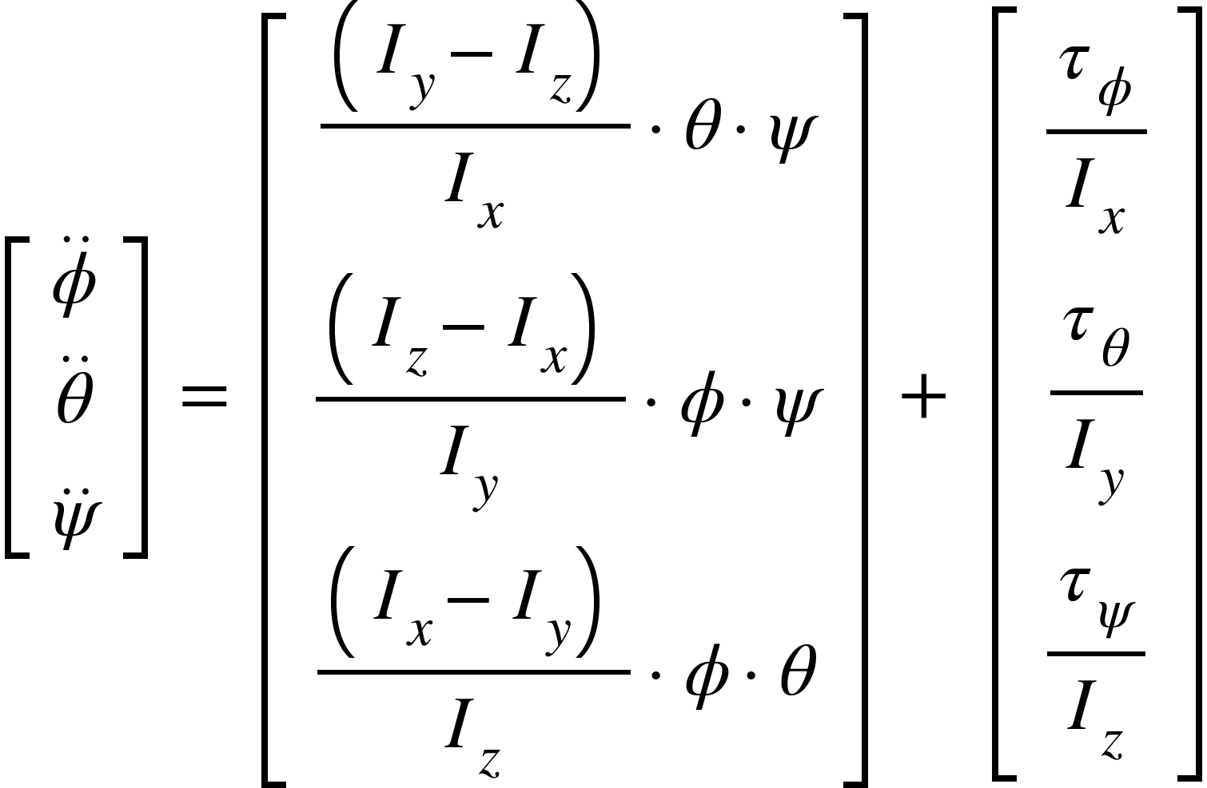

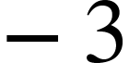

And the actuator dynamics is as follows

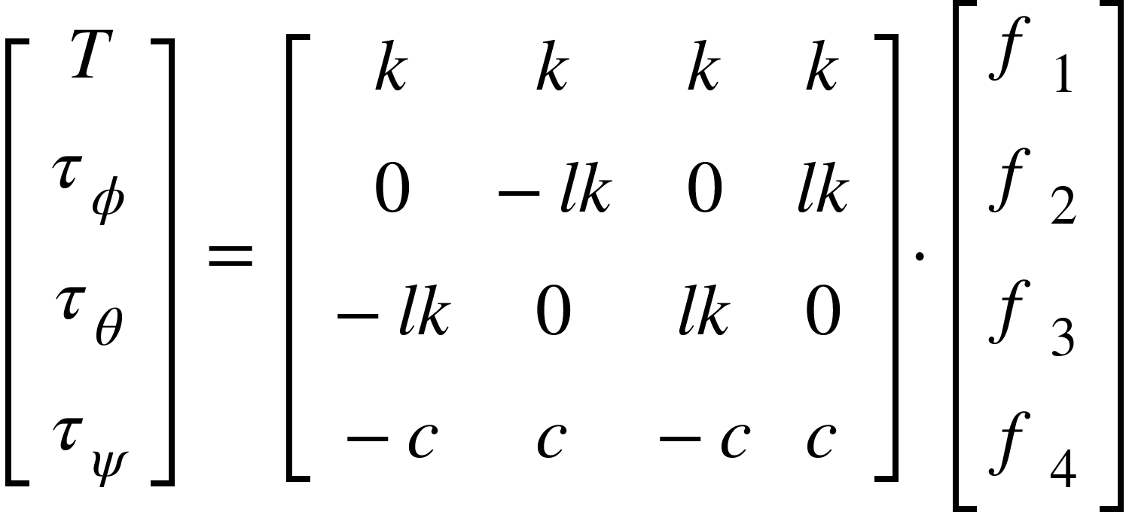

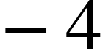

<math xmlns="http://www.w3.org/1998/Math/MathML"><mi>w</mi><mi>h</mi><mi>e</mi><mi>r</mi><mi>e</mi><mo>,</mo><mspace linebreak="newline"/><mi>x</mi><mo>,</mo><mo>&#xA0;</mo><mi>y</mi><mo>,</mo><mo>&#xA0;</mo><mi>z</mi><mo>&#xA0;</mo><mo>&#xA0;</mo><mo>&#xA0;</mo><mo>&#xA0;</mo><mo>&#xA0;</mo><mo>&#xA0;</mo><mo>&#xA0;</mo><mo>&#xA0;</mo><mo>&#xA0;</mo><mo>-</mo><mo>&#xA0;</mo><mi>d</mi><mi>i</mi><mi>s</mi><mi>p</mi><mi>l</mi><mi>a</mi><mi>c</mi><mi>e</mi><mi>m</mi><mi>e</mi><mi>n</mi><mi>t</mi><mi>s</mi><mo>&#xA0;</mo><mi>i</mi><mi>n</mi><mo>&#xA0;</mo><mi>i</mi><mi>n</mi><mi>e</mi><mi>r</mi><mi>t</mi><mi>i</mi><mi>a</mi><mi>l</mi><mo>&#xA0;</mo><mi>f</mi><mi>r</mi><mi>a</mi><mi>m</mi><mi>e</mi><mo>&#xA0;</mo><mi>o</mi><mi>f</mi><mo>&#xA0;</mo><mi>r</mi><mi>e</mi><mi>f</mi><mi>e</mi><mi>r</mi><mi>e</mi><mi>n</mi><mi>c</mi><mi>e</mi><mspace linebreak="newline"/><mi>&#x3D5;</mi><mo>,</mo><mo>&#xA0;</mo><mi>&#x3B8;</mi><mo>,</mo><mo>&#xA0;</mo><mi>&#x3C8;</mi><mo>&#xA0;</mo><mo>&#xA0;</mo><mo>&#xA0;</mo><mo>&#xA0;</mo><mo>&#xA0;</mo><mo>&#xA0;</mo><mo>&#xA0;</mo><mo>-</mo><mo>&#xA0;</mo><mi>e</mi><mi>u</mi><mi>l</mi><mi>e</mi><mi>r</mi><mo>&#xA0;</mo><mi>a</mi><mi>n</mi><mi>g</mi><mi>l</mi><mi>e</mi><mi>s</mi><mo>&#xA0;</mo><mfenced><mrow><mi>r</mi><mi>o</mi><mi>l</mi><mi>l</mi><mo>,</mo><mi>p</mi><mi>i</mi><mi>t</mi><mi>c</mi><mi>h</mi><mo>,</mo><mi>y</mi><mi>a</mi><mi>w</mi></mrow></mfenced><mo>&#xA0;</mo><mi>i</mi><mi>n</mi><mo>&#xA0;</mo><mi>i</mi><mi>n</mi><mi>e</mi><mi>r</mi><mi>t</mi><mi>i</mi><mi>a</mi><mi>l</mi><mo>&#xA0;</mo><mi>f</mi><mi>r</mi><mi>a</mi><mi>m</mi><mi>e</mi><mo>&#xA0;</mo><mi>o</mi><mi>f</mi><mo>&#xA0;</mo><mi>r</mi><mi>e</mi><mi>f</mi><mi>e</mi><mi>r</mi><mi>e</mi><mi>n</mi><mi>c</mi><mi>e</mi><mspace linebreak="newline"/><mi>m</mi><mo>,</mo><mo>&#xA0;</mo><mi>l</mi><mo>&#xA0;</mo><mo>&#xA0;</mo><mo>&#xA0;</mo><mo>&#xA0;</mo><mo>&#xA0;</mo><mo>&#xA0;</mo><mo>&#xA0;</mo><mo>&#xA0;</mo><mo>&#xA0;</mo><mo>&#xA0;</mo><mo>&#xA0;</mo><mo>&#xA0;</mo><mo>&#xA0;</mo><mo>-</mo><mo>&#xA0;</mo><mi>m</mi><mi>a</mi><mi>s</mi><mi>s</mi><mo>&#xA0;</mo><mi>a</mi><mi>n</mi><mi>d</mi><mo>&#xA0;</mo><mi>f</mi><mi>r</mi><mi>a</mi><mi>m</mi><mi>e</mi><mo>&#xA0;</mo><mi>l</mi><mi>e</mi><mi>n</mi><mi>g</mi><mi>t</mi><mi>h</mi><mo>&#xA0;</mo><mi>o</mi><mi>f</mi><mo>&#xA0;</mo><mi>t</mi><mi>h</mi><mi>e</mi><mo>&#xA0;</mo><mi>q</mi><mi>u</mi><mi>a</mi><mi>d</mi><mi>r</mi><mi>o</mi><mi>t</mi><mi>o</mi><mi>r</mi><mspace linebreak="newline"/><msub><mi>&#x3C4;</mi><mi>&#x3D5;</mi></msub><mo>,</mo><mo>&#xA0;</mo><msub><mi>&#x3C4;</mi><mi>&#x3B8;</mi></msub><mo>,</mo><mo>&#xA0;</mo><msub><mi>&#x3C4;</mi><mi>&#x3C8;</mi></msub><mo>&#xA0;</mo><mo>&#xA0;</mo><mo>-</mo><mo>&#xA0;</mo><mi>t</mi><mi>o</mi><mi>r</mi><mi>q</mi><mi>u</mi><mi>e</mi><mi>s</mi><mo>&#xA0;</mo><mi>a</mi><mi>l</mi><mi>o</mi><mi>n</mi><mi>g</mi><mo>&#xA0;</mo><mi>t</mi><mi>h</mi><mi>e</mi><mo>&#xA0;</mo><mi>r</mi><mi>e</mi><mi>s</mi><mi>p</mi><mi>e</mi><mi>c</mi><mi>t</mi><mi>i</mi><mi>v</mi><mi>e</mi><mo>&#xA0;</mo><mi>a</mi><mi>x</mi><mi>e</mi><mi>s</mi><mspace linebreak="newline"/><mi>T</mi><mo>&#xA0;</mo><mo>&#xA0;</mo><mo>&#xA0;</mo><mo>&#xA0;</mo><mo>&#xA0;</mo><mo>&#xA0;</mo><mo>&#xA0;</mo><mo>&#xA0;</mo><mo>&#xA0;</mo><mo>&#xA0;</mo><mo>&#xA0;</mo><mo>&#xA0;</mo><mo>&#xA0;</mo><mo>&#xA0;</mo><mo>&#xA0;</mo><mo>&#xA0;</mo><mo>&#xA0;</mo><mo>&#xA0;</mo><mo>-</mo><mi>t</mi><mi>h</mi><mi>r</mi><mi>u</mi><mi>s</mi><msub><mi>t</mi><mrow/></msub><mspace linebreak="newline"/><mspace linebreak="newline"/></math>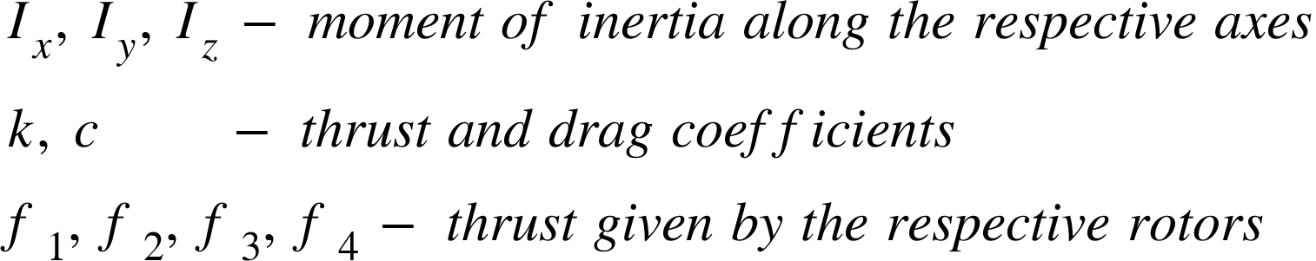

**METHODS USED FOR TRAJECTORY TRACKING**

A variety of control algorithms were designed, they are listed below

1. PID controller
2. Backstepping control
3. Sliding Mode control
4. Super Twisting Sliding mode control

Super Twisting sliding mode control proved to show better results for underactuated systems. It will be discussed in detail in the report.

**SMC Controller Design**

A sliding mode controller (SMC) is used to control the quadrotor. One of the main reasons for using sliding mode controller is that it is insensitive to unmodelled disturbances. It is a Nonlinear controller, our modelling and control design will be more accurate than linear controllers. And its been proven to work well for under-actuated systems.

Let the sliding surface be

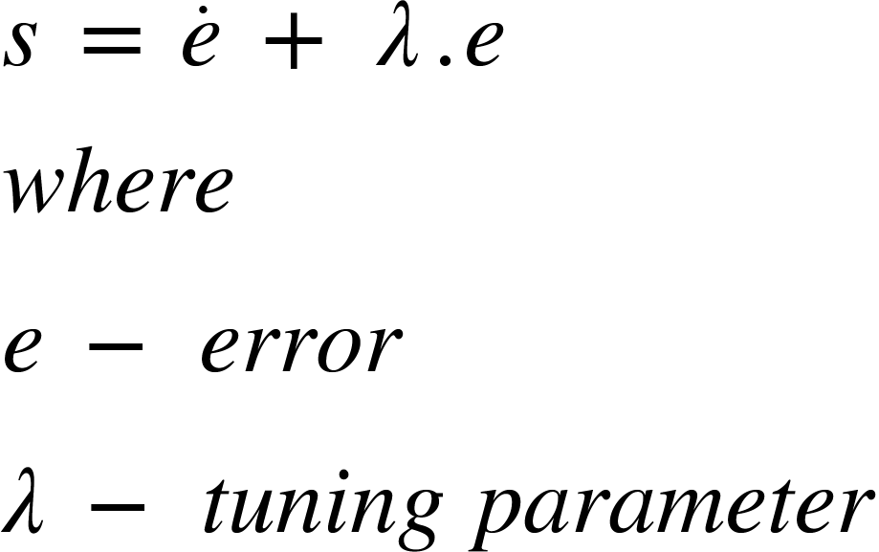

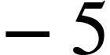

And the sliding variables that are considered for designing the controller are

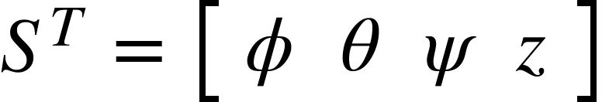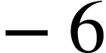

In order to control the quadrotor to the desired trajectory the sliding variables should reach the sliding surface in finite time and slide the surface. Combining equations 2,3,5 and 6 and equating <math xmlns="http://www.w3.org/1998/Math/MathML"><mover><mi>s</mi><mo>&#x2D9;</mo></mover></math> to zero. The equivalent control can be given as

<math xmlns="http://www.w3.org/1998/Math/MathML"><mover><msub><mi>u</mi><mi>&#x3D5;</mi></msub><mo>^</mo></mover><mo>&#xA0;</mo><mo>=</mo><mfrac><mrow><mo>&#xA0;</mo><msub><mi>I</mi><mi>x</mi></msub></mrow><mi>l</mi></mfrac><mo>&#xB7;</mo><mfenced><mrow><mo>-</mo><mover><mi>&#x3B8;</mi><mo>&#x2D9;</mo></mover><mo>&#xB7;</mo><mover><mi>&#x3C8;</mi><mo>&#x2D9;</mo></mover><mo>&#xB7;</mo><mfrac><mfenced><mrow><msub><mi>I</mi><mi>y</mi></msub><mo>-</mo><msub><mi>I</mi><mi>z</mi></msub></mrow></mfenced><msub><mi>I</mi><mi>x</mi></msub></mfrac><mo>+</mo><mover><msub><mi>&#x3D5;</mi><mi>d</mi></msub><mo>&#xA8;</mo></mover><mo>-</mo><mi>&#x3BB;</mi><mo>&#xB7;</mo><mfenced><mrow><mover><msub><mi>&#x3D5;</mi><mi>d</mi></msub><mo>&#x2D9;</mo></mover><mo>-</mo><mover><mi>&#x3D5;</mi><mo>&#x2D9;</mo></mover></mrow></mfenced></mrow></mfenced><mspace linebreak="newline"/><mover><msub><mi>u</mi><mi>&#x3B8;</mi></msub><mo>^</mo></mover><mo>&#xA0;</mo><mo>=</mo><mfrac><mrow><mo>&#xA0;</mo><msub><mi>I</mi><mi>y</mi></msub></mrow><mi>l</mi></mfrac><mo>&#xB7;</mo><mfenced><mrow><mo>-</mo><mover><mi>&#x3D5;</mi><mo>&#x2D9;</mo></mover><mo>&#xB7;</mo><mover><mi>&#x3C8;</mi><mo>&#x2D9;</mo></mover><mo>&#xB7;</mo><mfrac><mfenced><mrow><msub><mi>I</mi><mi>z</mi></msub><mo>-</mo><msub><mi>I</mi><mi>x</mi></msub></mrow></mfenced><msub><mi>I</mi><mi>y</mi></msub></mfrac><mo>+</mo><mover><msub><mi>&#x3B8;</mi><mi>d</mi></msub><mo>&#xA8;</mo></mover><mo>-</mo><mi>&#x3BB;</mi><mo>&#xB7;</mo><mfenced><mrow><mover><msub><mi>&#x3B8;</mi><mi>d</mi></msub><mo>&#x2D9;</mo></mover><mo>-</mo><mover><mi>&#x3B8;</mi><mo>&#x2D9;</mo></mover></mrow></mfenced></mrow></mfenced><mspace linebreak="newline"/><mover><msub><mi>u</mi><mi>&#x3C8;</mi></msub><mo>^</mo></mover><mo>&#xA0;</mo><mo>=</mo><mfrac><mrow><mo>&#xA0;</mo><msub><mi>I</mi><mi>z</mi></msub><mo>&#xA0;</mo></mrow><mi>l</mi></mfrac><mo>&#xB7;</mo><mfenced><mrow><mo>-</mo><mover><mi>&#x3B8;</mi><mo>&#x2D9;</mo></mover><mo>&#xB7;</mo><mover><mi>&#x3D5;</mi><mo>&#x2D9;</mo></mover><mo>&#xB7;</mo><mfrac><mfenced><mrow><msub><mi>I</mi><mi>x</mi></msub><mo>-</mo><msub><mi>I</mi><mi>y</mi></msub></mrow></mfenced><msub><mi>I</mi><mi>z</mi></msub></mfrac><mo>+</mo><mover><msub><mi>&#x3C8;</mi><mi>d</mi></msub><mo>&#xA8;</mo></mover><mo>-</mo><mi>&#x3BB;</mi><mo>&#xB7;</mo><mfenced><mrow><mover><msub><mi>&#x3C8;</mi><mi>d</mi></msub><mo>&#x2D9;</mo></mover><mo>-</mo><mover><mi>&#x3C8;</mi><mo>&#x2D9;</mo></mover></mrow></mfenced></mrow></mfenced><mspace linebreak="newline"/><mover><mi>T</mi><mo>^</mo></mover><mo>&#xA0;</mo><mo>=</mo><mfrac><mrow><mo>&#xA0;</mo><mi>m</mi><mo>&#xA0;</mo></mrow><mrow><mi>cos</mi><mi>&#x3D5;</mi><mi>cos</mi><mi>&#x3B8;</mi></mrow></mfrac><mo>&#xB7;</mo><mfenced><mrow><mi>g</mi><mo>+</mo><mover><msub><mi>z</mi><mi>d</mi></msub><mo>&#xA8;</mo></mover><mo>-</mo><mi>&#x3BB;</mi><mo>&#xB7;</mo><mfenced><mrow><mover><msub><mi>z</mi><mi>d</mi></msub><mo>&#x2D9;</mo></mover><mo>-</mo><mover><mi>z</mi><mo>&#x2D9;</mo></mover></mrow></mfenced></mrow></mfenced></math>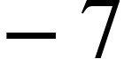

Inorder to satisfy the sliding reachability condition a discontinuous term is included to the equivalent control

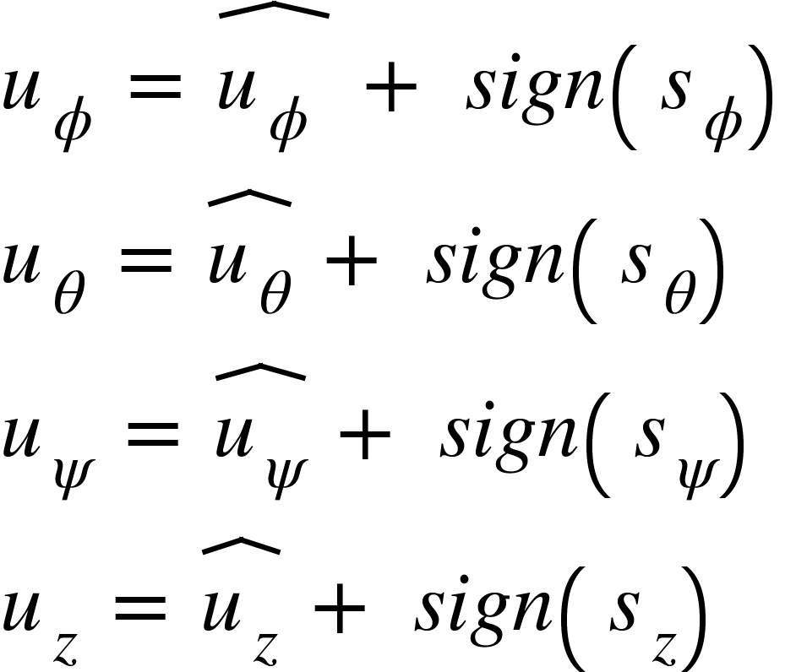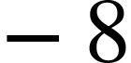

The sign function being discontinuous will give a high frequency oscillation called chattering effect. This effect makes the practical implementation quite difficult. So we use an alternative continuous function instead of sign function

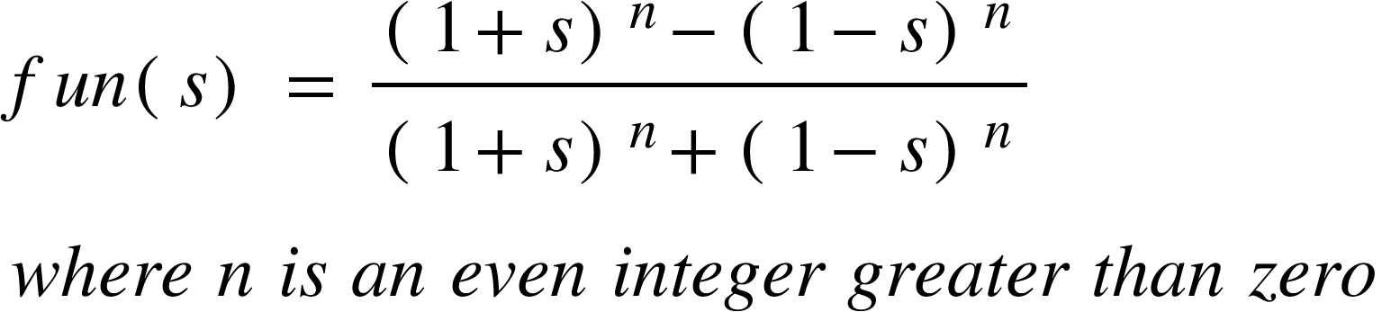

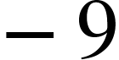

Comparison between sign(s) and fun(s),

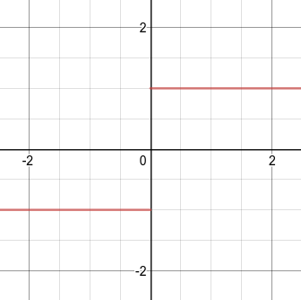 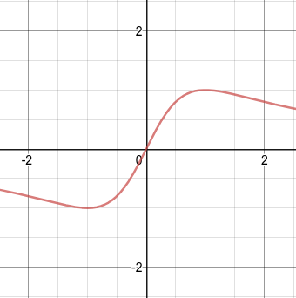 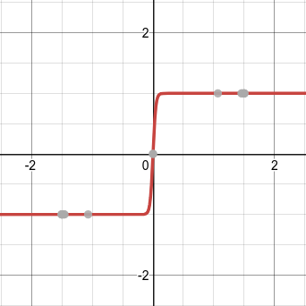

sign(s) fun(s), n=2 fun(s), n=22

This function reduced chattering upto some extent. The calculated control input will drive the quadrotor to track a specific trajectory.

**Super Twisting SMC:**

The input equations for super twisting sliding mode are calculated as follows

<math xmlns="http://www.w3.org/1998/Math/MathML"><msub><mi>u</mi><mi>&#x3D5;</mi></msub><mo>&#xA0;</mo><mo>=</mo><mo>&#xA0;</mo><mover><mrow><msub><mi>u</mi><mi>&#x3D5;</mi></msub><mo>&#xA0;</mo></mrow><mo>^</mo></mover><mo>&#xA0;</mo><mo>-</mo><mo>&#xA0;</mo><mn>1</mn><mo>.</mo><mn>5</mn><mo>&#xB7;</mo><msup><msub><mi>k</mi><mn>1</mn></msub><mstyle displaystyle="false"><mfrac bevelled="true"><mn>1</mn><mn>2</mn></mfrac></mstyle></msup><mo>&#xB7;</mo><msup><msub><mi>s</mi><mi>&#x3D5;</mi></msub><mfrac bevelled="true"><mn>1</mn><mn>2</mn></mfrac></msup><mo>&#xA0;</mo><mo>&#xB7;</mo><mi>s</mi><mi>i</mi><mi>g</mi><mi>n</mi><mfenced><msub><mi>s</mi><mi>&#x3D5;</mi></msub></mfenced><mo>&#xA0;</mo><mo>-</mo><mo>&#xA0;</mo><mo>&#x222B;</mo><mn>1</mn><mo>.</mo><mn>1</mn><mo>&#xB7;</mo><msub><mi>k</mi><mn>1</mn></msub><mo>&#xB7;</mo><mi>s</mi><mi>i</mi><mi>g</mi><mi>n</mi><mfenced><msub><mi>s</mi><mi>&#x3D5;</mi></msub></mfenced><mspace linebreak="newline"/><msub><mi>u</mi><mi>&#x3B8;</mi></msub><mo>&#xA0;</mo><mo>=</mo><mo>&#xA0;</mo><mover><msub><mi>u</mi><mi>&#x3B8;</mi></msub><mo>^</mo></mover><mo>&#xA0;</mo><mo>&#xA0;</mo><mo>-</mo><mo>&#xA0;</mo><mn>1</mn><mo>.</mo><mn>5</mn><mo>&#xB7;</mo><msup><msub><mi>k</mi><mn>2</mn></msub><mstyle displaystyle="false"><mfrac bevelled="true"><mn>1</mn><mn>2</mn></mfrac></mstyle></msup><mo>&#xB7;</mo><msup><msub><mi>s</mi><mi>&#x3B8;</mi></msub><mfrac bevelled="true"><mn>1</mn><mn>2</mn></mfrac></msup><mo>&#xA0;</mo><mo>&#xB7;</mo><mi>s</mi><mi>i</mi><mi>g</mi><mi>n</mi><mfenced><msub><mi>s</mi><mi>&#x3B8;</mi></msub></mfenced><mo>&#xA0;</mo><mo>-</mo><mo>&#xA0;</mo><mo>&#x222B;</mo><mn>1</mn><mo>.</mo><mn>1</mn><mo>&#xB7;</mo><msub><mi>k</mi><mn>2</mn></msub><mo>&#xB7;</mo><mi>s</mi><mi>i</mi><mi>g</mi><mi>n</mi><mfenced><msub><mi>s</mi><mi>&#x3B8;</mi></msub></mfenced><mspace linebreak="newline"/><msub><mi>u</mi><mi>&#x3C8;</mi></msub><mo>&#xA0;</mo><mo>=</mo><mo>&#xA0;</mo><mover><msub><mi>u</mi><mi>&#x3C8;</mi></msub><mo>^</mo></mover><mo>&#xA0;</mo><mo>&#xA0;</mo><mo>-</mo><mo>&#xA0;</mo><mn>1</mn><mo>.</mo><mn>5</mn><mo>&#xB7;</mo><msup><msub><mi>k</mi><mn>3</mn></msub><mstyle displaystyle="false"><mfrac bevelled="true"><mn>1</mn><mn>2</mn></mfrac></mstyle></msup><mo>&#xB7;</mo><msup><msub><mi>s</mi><mi>&#x3C8;</mi></msub><mfrac bevelled="true"><mn>1</mn><mn>2</mn></mfrac></msup><mo>&#xA0;</mo><mo>&#xB7;</mo><mi>s</mi><mi>i</mi><mi>g</mi><mi>n</mi><mfenced><msub><mi>s</mi><mi>&#x3C8;</mi></msub></mfenced><mo>&#xA0;</mo><mo>-</mo><mo>&#xA0;</mo><mo>&#x222B;</mo><mn>1</mn><mo>.</mo><mn>1</mn><mo>&#xB7;</mo><msub><mi>k</mi><mn>3</mn></msub><mo>&#xB7;</mo><mi>s</mi><mi>i</mi><mi>g</mi><mi>n</mi><mfenced><msub><mi>s</mi><mi>&#x3C8;</mi></msub></mfenced><mspace linebreak="newline"/><msub><mi>u</mi><mi>z</mi></msub><mo>&#xA0;</mo><mo>=</mo><mo>&#xA0;</mo><mover><msub><mi>u</mi><mi>z</mi></msub><mo>^</mo></mover><mo>&#xA0;</mo><mo>&#xA0;</mo><mo>-</mo><mo>&#xA0;</mo><mn>1</mn><mo>.</mo><mn>5</mn><mo>&#xB7;</mo><msup><msub><mi>k</mi><mn>4</mn></msub><mstyle displaystyle="false"><mfrac bevelled="true"><mn>1</mn><mn>2</mn></mfrac></mstyle></msup><mo>&#xB7;</mo><msup><msub><mi>s</mi><mi>z</mi></msub><mfrac bevelled="true"><mn>1</mn><mn>2</mn></mfrac></msup><mo>&#xA0;</mo><mo>&#xB7;</mo><mi>s</mi><mi>i</mi><mi>g</mi><mi>n</mi><mfenced><msub><mi>s</mi><mi>z</mi></msub></mfenced><mo>&#xA0;</mo><mo>-</mo><mo>&#xA0;</mo><mo>&#x222B;</mo><mn>1</mn><mo>.</mo><mn>1</mn><mo>&#xB7;</mo><msub><mi>k</mi><mn>4</mn></msub><mo>&#xB7;</mo><mi>s</mi><mi>i</mi><mi>g</mi><mi>n</mi><mfenced><msub><mi>s</mi><mi>z</mi></msub></mfenced><mspace linebreak="newline"/></math>

**Control Allocation**

When one of the actuators loses its effectiveness partially/whole, the controller should be in a position to counter the loss effectiveness and continue the trajectory tracking or control the quadrotor to safety.

Let the control effectiveness vector be represented as,

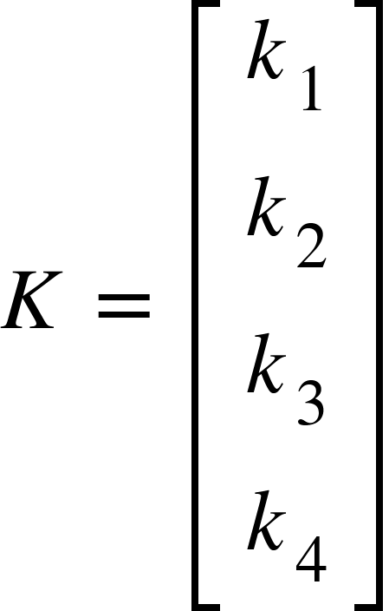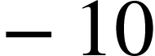

We can detect the faults and obtain the values of control effectiveness vector (K) through an extended kalman filter. Once the values of the control effectiveness vector are obtained, control allocation of the inputs is done accordingly to counteract the faults.

Suppose if a propeller is partially actuated and the propeller output us half of the expected output (ie. k = 0.5). The opposite propeller is made to actuate only half of its current expected output. This makes sure that roll and pitch torque are balanced, but ignores the torque in yaw axis.

Control output after fault detection is given by,

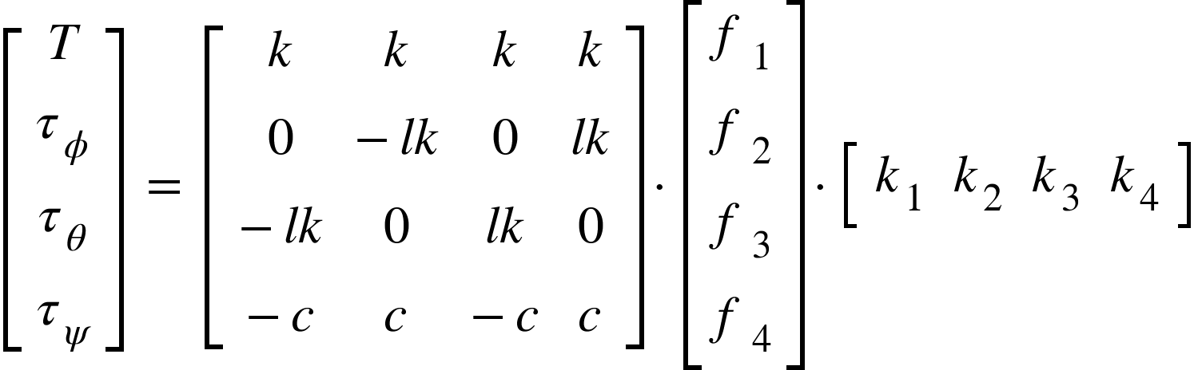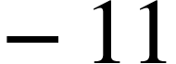

Once the faults are detected the propeller output is calculated according to the control allocation as given below

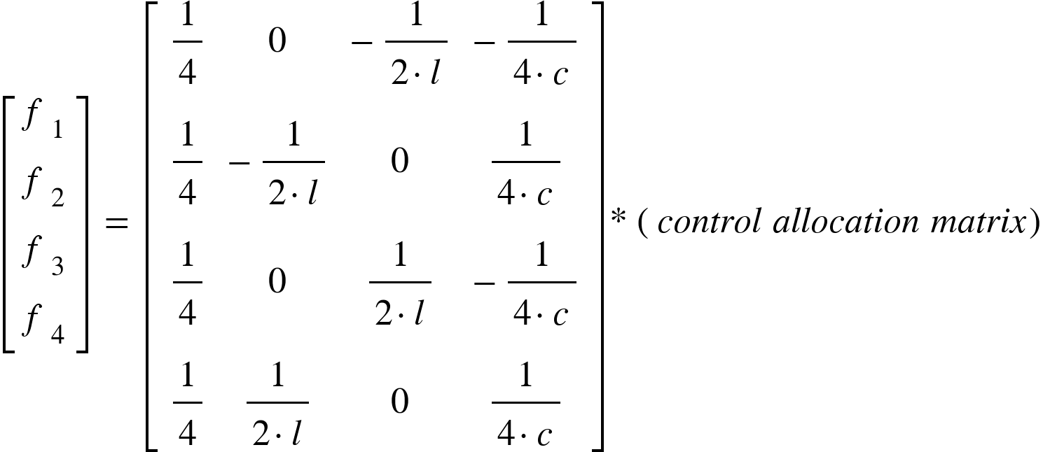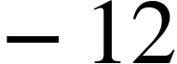

The control system block diagram of the sliding mode controller along with the fault tolerant control system is given below

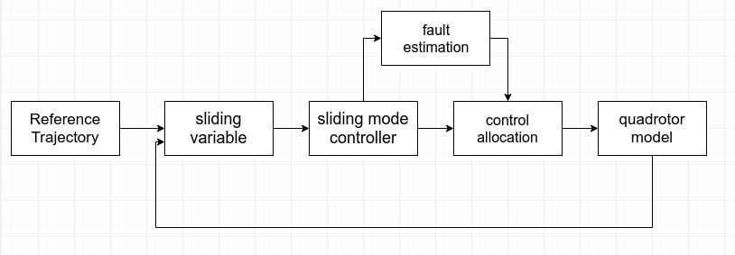

**RESULTS**

The derived controller is developed in MATLAB and SIMULINK environment along with the quadrotor model. The parameters of parrot AR drone are considered while modelling the quadrotor .

The simulation runs for 100s. A quadrotor is made to track a given trajectory. A fault is introduced in propeller 1 (k1 = 0.5) at 30s.

The control allocation is able to tolerate faults upto 80 percent loss. The quadrotor is able to track the trajectory perfectly if the loss effectiveness is below 80 percent (k = 0.2). The results below shows the comparative analysis on control of quadrotor with and without control allocation

**Tracking results:**

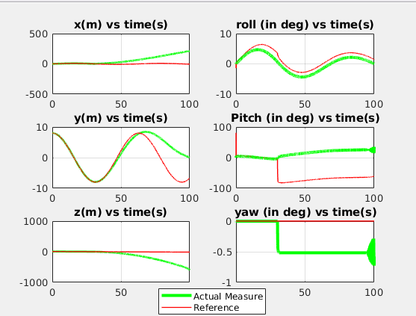

Super twisting control without control allocation

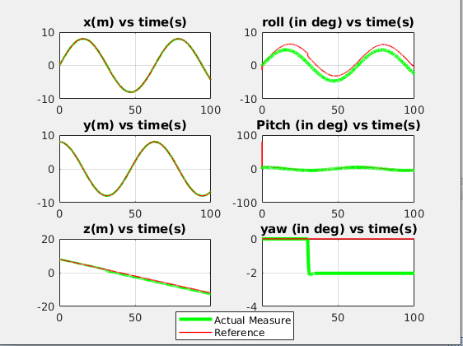

Super twisting control with control allocation

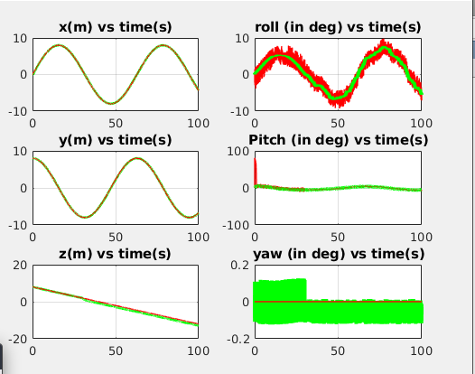

Nominal Sliding mode control with control allocation

**Control inputs:**

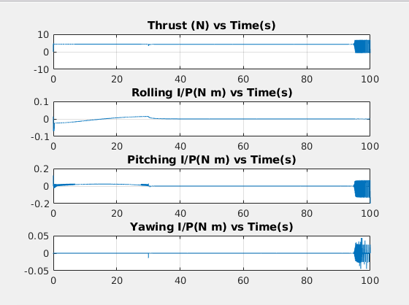

Super twisting control without control allocation

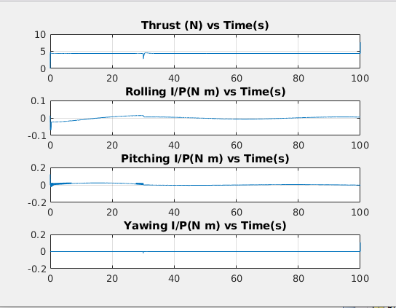

Super twisting with control allocation

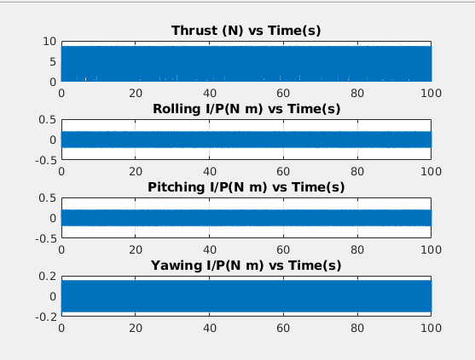

Nominal Sliding mode control with control allocation

**Error:**

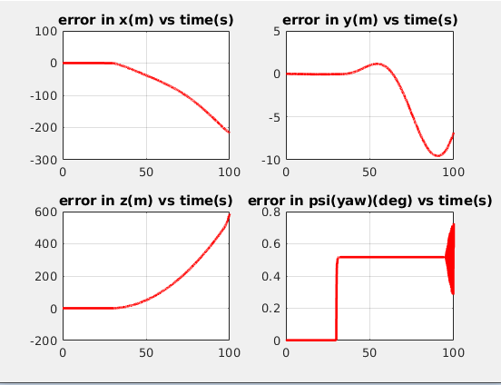

Super twisting SMC without control allocation

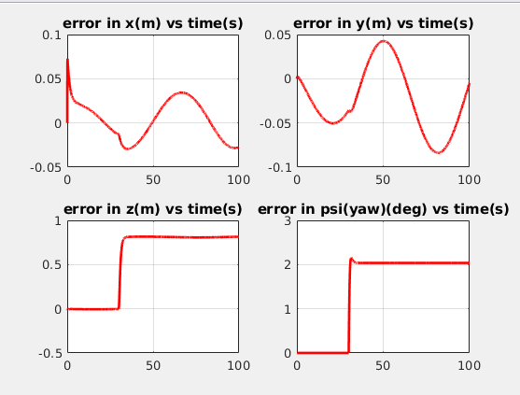

Super twisting SMC with control allocation

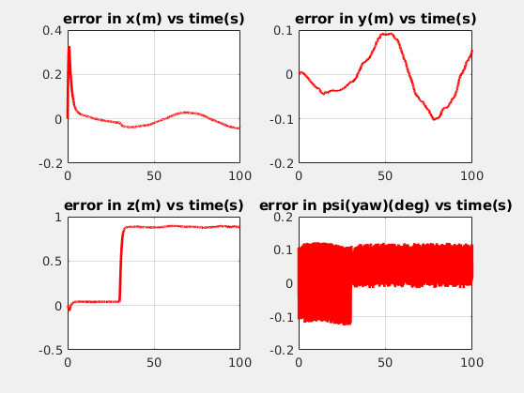

Nominal SMC with control allocation

**SUMMARY**

A fault tolerant controller of a quadrotor has been designed to land a quadrotor safely under faulty circumstances.